Design Document : “HireMe Net”

**Introduction:**

"HireMe Net" is a web-based job portal designed to streamline the job search process and provide valuable insights into market salaries for various roles. The platform caters to both job seekers and employers, offering a user-friendly interface to search for jobs, view market salaries, and facilitate the hiring process.

**User Roles:**

"HireMe Net" supports two main user roles:

**Job Seekers:** Individuals actively seeking employment, searching for specific job roles.

**Employers:** Companies looking to post job listings, manage applications, and gain insights into market salaries for various positions.

**Technology Stack**

**Frontend**

● **React.js**: The front end of the real estate website will be built using React.js, leveraging its component-based architecture for creating dynamic user interfaces.

● **React Router**: React Router will handle client-side routing, enabling navigation between different pages of the website without full page reloads.

● **Tailwind CSS**: Tailwind CSS will be used for styling the website. Its utility-first approach allows for rapid development and customization of the user interface.

● **Axios**: Axios will handle HTTP requests from the frontend to the backend API, facilitating data fetching and interaction with the server.

**Backend**

● **Node.js**: The backend of the website will be powered by Node.js, allowing for the development of scalable and efficient server-side applications using JavaScript.

● **Express.js**: Express.js will handle routing, middleware, and HTTP requests on the server side, providing a robust foundation for building RESTful APIs.

● **MongoDB**: MongoDB will store data for the real estate website. Its flexibility and scalability make it suitable for storing various types of data, including user profiles, property listings, and related information.

● **Mongoose**: Mongoose will simplify interactions with the MongoDB database, providing schema validation and modeling capabilities.

**Database Design:**

MongoDB collections include:

**Users:** Stores user details, including name, email, password hash, and role.

**Jobs:** Contains job listings with details like title, description, company, location, and application deadlines.

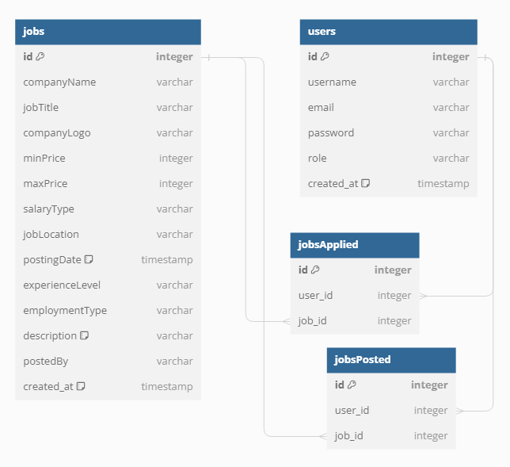

**API Design:**

The backend offers these APIs:

**Authentication APIs:**

/api/user/register: Register a new user.

/api/user/login: Authenticate user credentials and generate a JWT token.

/api/user/profile: Get current user details.

**Job APIs:**

/api/employee/jobs: Get all jobs or create a new job listing.

/api/employee/jobs/:id: Get, update, or delete a specific job by ID.

/api/employee/jobs/search/:role: Search for jobs based on a specific role.

/api/employee/applied-jobs: Get jobs applied by the user.

**Employer APIs:**

/api/employer/post-job: Post a new job listing.

/api/employer/my-jobs: Get jobs posted by the employer.

**Admin APIs:**

/api/admin/all-users: Get details of all users.

/api/admin/all-jobs: Get details of all jobs.

/api/admin/manage-job/:jobId : Manage job status.

**Frontend Design:**

Designed with React.js and styled using Tailwind CSS

**Job Search Section:** Displays a list of job listings with filtering options by role, location, and industry.

**Market Salaries Section:** Presents insights into market salaries for various roles and industries.

**User Profile:** Allows users to manage their profile details and track job applications.

**Employer Dashboard:** Enables employers to post jobs, manage listings, and view applicant details.  
**Admin Dashboard** : Allows the admin to manage the jobs posted and the avg. salary page

**Filtering Options**

**1.Search**

●Users can search for jobs using a search bar, allowing them to search jobs based on role.

●The search functionality will filter jobs based on the entered query and display matching results in real time.

**2.Location**

●Users can filter Jobs based on the location.

**3.Salary**

●Users can sort Jobs based on minimum salary .

**Deployment**

● **Vercel**: The real estate website will be deployed on Vercel, leveraging its seamless integration with the MERN stack, continuous deployment capabilities, and serverless architecture.

● **GitHub**: The website's source code will be hosted on GitHub for version control and collaboration, enabling automated deployments to Vercel.

**Security:**

Implement security measures, including input validation, protection against common web vulnerabilities, and secure JWT-based authentication mechanisms.

**Maintenance and Support:**

Regularly update the platform to incorporate the latest technologies and security patches. Establish a support system to address user inquiries, bug reports, and feature requests promptly.

**Conclusion:**

"HireMe Net" aims to provide a seamless job search experience and valuable market insights to users. By adhering to the outlined design principles, the platform endeavors to connect job seekers with opportunities and empower employers in their hiring processes.